Final Evaluation Submission Workflow

Seattle wants a more granular workflow for tracking the steps toward the final submission. To support this we will add a new District Admin Setup feature that will allow the DA to configure whether they want the default, simple workflow, or the more granular one that Seattle has helped us design.

Default Workflow:

* Evaluation is in one of two workstates: Submitted | Not Submitted. The evaluator can submit the evaluation once all the required scores have been completed. Once the evaluation has been submitted, the district administrator is able to “Un-submit” the evaluation and it will return to the Not Submitted workstate.

Advanced Workflow:

|  |  |  |  |
| --- | --- | --- | --- |
| **Start WorkState** | **End WorkState** | **User** | **Transition** |
| Has Not Been Submitted | Ready For Evaluation Conference | Principal | Submit for Evaluation Conference |
| Ready For Evaluation Conference | Ready For Teacher Receipt | Principal | Submit for Teacher Receipt/Acknowledgement |
| Ready for Teacher Receipt | Ready for Submission | Teacher | Acknowledges Receipt |
| Ready For Submission | Submitted | Principal | Submit |

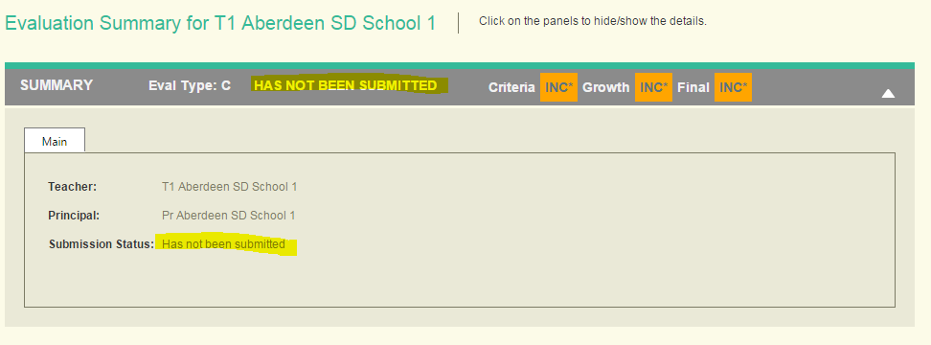

Changes to Summary Panel on Evaluation Summary Screen

* Continue to display current Submission Status on the panel header.
* Change the Submission Status displayed within the panel to show the current status, plus a button to the right of the next action if it has not yet been submitted